PRESS RELEASE
For immediate release

CROSSCALL WINS THE CONTRACT TO SUPPLY
MOBILE PHONE EQUIPMENT TO
THE SNCF RAILWAY AGENTS
IN THIS HIGHLY COMPETITIVE MARKET
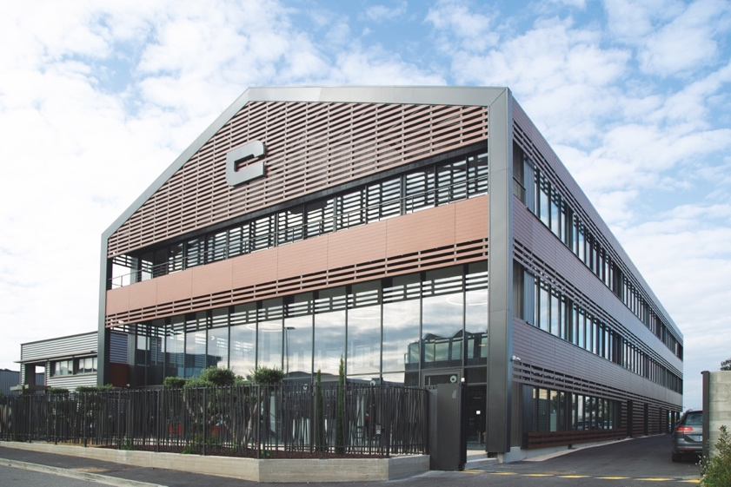

The international brand, specialised in durable smartphones, which celebrates its 10th anniversary this year, made a remarkable breakthrough into the public service market, winning its largest professional contract to date, which will cover a three-year period.

Aix-en-Provence, France, October 14, 2019 – Crosscall, the outdoors mobile technology specialist, having delighted in the past decade extreme sports athletes and other amateurs of open spaces, has intensified its hold on professional markets, thanks to its range of durable, waterproof smartphones with a long-lasting battery-life. The revenues of the ex- start-up from the South of France increased by 40% to 71.6 million euros during the fiscal year 2018-2019. The durability and sustainability of its products make them very attractive to professionals.

A DECISIVE MARKET FOR THE FRENCH SCALE-UP COMPANY

Crosscall has been permanently growing and has already developed solid international markets in more than 16 countries. The company capitalises on its exceptional product performances to target professionals: a strong potential market for the brand representing half a million units sold over the 2018-2019 fiscal year and a total of two million since its creation.

The SNCF, the French train public service, is the second biggest rail network in Europe after Germany. It covers 30,000 km of railway tracks and carries over 1,11 billion passengers per year. The strategic importance of the professional market is undeniable for the company’s development and the SNCF Railway Agent Equipment Tender is clearly an economic challenge for Crosscall. The 3-year contract represents a total order of 21,500 Trekker-X4 Smartphones, the brand’s flagship product, a true recognition of the technological know-how of the company, on a national and even international basis. The durable phone brand has been put in the spotlight by one of the most important public services in France.

“I am very proud that the SNCF and its decision makers have chosen a French company for this tender. The 21,500 customer relationship agents working in the 3 business units “Voyages”, “TER” and “Intercité” will benefit from Crosscall’s advanced technological expertise knowing that the phones will be used at more than 300 km per hour on the rails. Crosscall and the Trekker-X4 mobiles will help us meet all the requirements of our various business needs,” announces enthusiastically Benoît Pasquier, Project Director at the Mobility Division of the SNCF's Onboard Staff Management.

In practical terms, the new Crosscall fleet will be deployed to customer relationship agents from the “Voyages TGV”, “TER” and “Intercité” business units: train controllers, train station staff, agents managing groups and those responsible for remote relationships. Globally, the agents concerned are the onboard and train station staff in charge of orienting and informing travellers. In addition, the SNCF corporate trainers, operational centres, and some management staff members will be equipped with a Crosscall Trekker-X4 mobile. The smartphones will be dedicated to professional use but the SNCF has already mentioned personal use would be tolerated.

To optimise implementation, 800 agents will be equipped during a pilot phase in November 2019. The rest of the fleet will be deployed during the first quarter 2020, aiming for completion by April 2020. A total of 18 towns and cities will host information meetings for the SNCF and Crosscall teams to present their new work tool to the agents.

A DECISIVE CRITERION: DURABILITY

Amongst the many criteria defined in the tender, it’s Crosscall’s product durability that convinced the French Railway Public Service to favour the French brand.

The SNCF asked Greenspector, an independent lab, to estimate the battery life of different brands. These tests were done under serious field constraints, one being how long a battery keeps a minimum of 10 hours of autonomy. For Crosscall products, the estimated time before replacement was 39 nine months, which gave the firm the best mark, with a full year more battery life and durability compared to the best performing competitors in this test. The deployed Trekker-X4s will therefore cover the complete three-year contract duration and even more, which renders the Total Cost of Ownership of Crosscall’s fleet very attractive.

Amongst other favourable criteria for the brand, another notable one was the network reception as Crosscall’s smartphones have proved to have the best reception with the least interruptions in all situations, including at 300 km per hour and including tests with different service providers.

With an overall mark of 90.1/100 in the tests carried out by Greenspector lab, Crosscall has a clear head start over its competitors, demonstrating the quality and technical performances of its smartphones.

Crosscall also scored well on the integration of business solutions and applications, thanks to a simple and quick implementation.

Last but not least, the Smartphones also stood out in the field tests under real-life conditions, where they were tested for two months by a panel of users from all activity sectors. Following these results, Crosscall was the SNCF staff’s most popular brand choice.

“Signing this 3-year contract with the SNCF is a real milestone in the brand’s development in the professional market. It represents a strategic focus and a powerful growth lever for Crosscall. We are always enthusiastic to see the success of our French jewel, and it reassures us in our aim to offer unique products that meet the needs and usage that other conventional smartphones do not and that favour durability. This partnership with such an important public service as the SNCF represents 10 years of non-stop work to bring Crosscall to the position where it is today, exporting to 16 countries and a reference in the B2B market,” declares Cyril Vidal, Founder and President of Crosscall.

ABOUT CROSSCALL

CROSSCALL, creator of the outdoor mobile technology market, offers waterproof, durable and highly autonomous mobiles and smartphones.
Cyril Vidal created Crosscall in 2009 to answer his specific needs as no existing mobiles met his expectations.
The brand designs models perfectly adapted to the hostile and unpredictable environments encountered by athletes and professionals in the field (water, rain, humidity, dust, shocks…); as well as a range of high-performance accessories. With more than two million units sold, a turnover of 71.6 million euros and more than 20,000 points of sale, the French company, based in Aix-en-Provence, is currently pursuing its international evolution moving its mobiles upmarket, increasingly recognised for their quality and originality across borders.

PRESS CONTACTS

Burson Cohn & Wolfe (PR agency)
Stéphanie Lasnel - +33 (0)1 56 03 13 45 - stephanie.lasnel@bcw-global.com
Bénédicte Fincker - +33 (0)1 56 03 12 21 – benedicte.fincker@bcw-global.com

CROSSCALL
Pauline Chanut - +33 (0)7 84 37 72 26 - pauline.chanut@crosscall.com

Lucas Giraud - +33 (0)7 63 11 34 63 – lucas.giraud@crosscall.com

